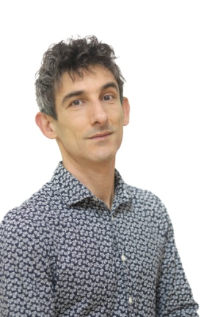
Marko Dinjaški
+381638700581
nelomarko@gmail.com
https://linktr.ee/vilovka

Born on December 9 1973 in Novi Sad, Serbia. Graduated from the primary music school in Novi Sad (major violin) and secondary military music school in Sarajevo (major musical performer, percussion, in the class of professors Panov Vasil and Fedor Vrtačnik, and violin).
Since 1998, he lives and works near Sremski Karlovci, on the outskirt of the national park "Fruška gora". Father of Alisa (22) and Vid (25). Participates in all activities of "Alice in Wonderband" body music duo, as theater and music performer, organizer, coordinator, author.
Multi-instrumentalist, plays ethnic instruments (tabla, tarabuk, didgeridoo) in addition to his native instrument (percussion).
One of the founders of the citizens' association "Open Circle Novi Sad", president. Since 2012, he has been applying the technique of body percussion and body music in performance and as an educator in workshops.
Member of the World Organization of Pantomimes since 2019. Member of UDUS (Association of Dramatic Arts of Serbia) and SOKOJ (Music Authors’ Association od Serbia) since 2020.
He performs in musical comedy "Kiss”, with that toured Germany, Italy, Austria, France, Turkey, Croatia, Bosnia, North Macedonia, Montenegro and Serbia.
He is leading the "Body as an Instrument" workshops with Ana Vrbaški since 2013, workshops of body music (body percussion and singing) that implement various theater games. They work with children, young people, adults, choirs, the elderly, and people with disabilities.
With “Alice in WonderBand” he performes the Balkan music concert that combines the cultural heritage of the Balkan countries with innovative musical arrangements. The music performed is from the musical album “RikaTaka, New Balkan Rhythm” released by German label CPL-Music in November of 2022.
He teaches drums and percussion to children at the music school "Do, re, mi" in Novi Sad.
For the children's program of TV Vojvodina, he composed and performed songs for the musical series “Centipede Rhymes", in cooperation with Ana Vrbaški.
He is one of the authors and producers of the accredited seminar "Rhymes and body music as a means of work in the development of speech in preschool children".
From 2022 one of the organizer, producers, teachers and performers at the first regional festival of body music in the ex-yu countries “New Balkan Rhythm”, that happens yearly in Sremski Karlovci, Serbia.

